## Bus Stop

Write a JS program that displays arrival times for all buses by a given bus stop ID when a button is clicked. Use the skeleton from the provided resources.

When the button with ID **'submit'** is clicked, the name of the bus stop appears and the list bellow gets filled with all the buses that are expected and their time of arrival. Take the **value** of the input field with id **'stopId'**. Submit a GET request to http://localhost:3030/jsonstore/bus/businfo/:busId (replace the highlighted part with the correct value) and parse the response. You will receive a JSON object in the format:

stopId: {

name: stopName,

buses: { busId: time, … }

}

Place the name property as text inside the div with ID **'stopName'** and each bus as a list item with text:

"Bus {busId} arrives in {time}"

Replace all highlighted parts with the relevant value from the response. If the request is not successful, or the information is not in the expected format, display **"Error"** as stopName and nothing in the list. The list should be cleared before every request is sent.

**Note:** The service will respond with valid data to IDs 1287, 1308, 1327 and 2334.

See examples on the next page.

### Examples

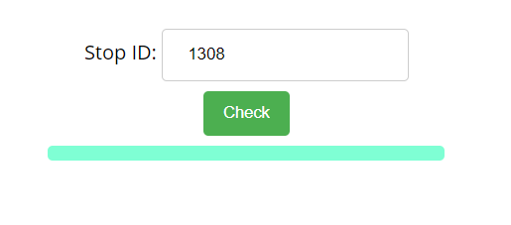

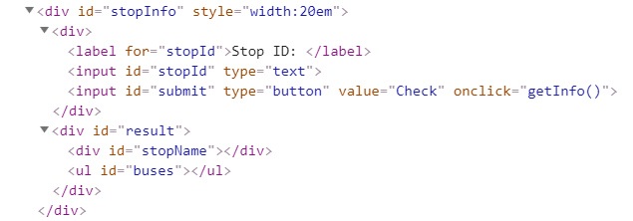

When the button is clicked, the results are displayed in the corresponding elements:

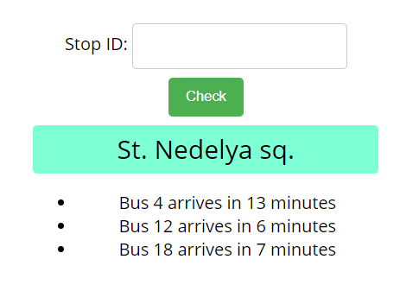

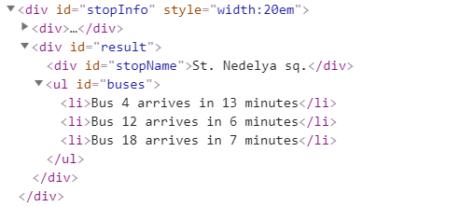

If an error occurs, the stop name changes to Error:

